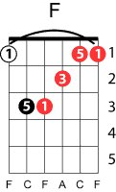
The Beatles – ‘til there was you
Meredith Meadows
key: F
Intro: F Fb2 Gm C7
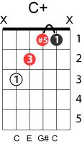
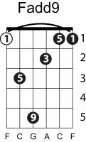
Verse 1
F Faddb9
There were bells on a hill
Gm B♭m
But I never heard them ringing
F Am G#m Gm
No I never heard them at all
C F Gm C
‘til there was you
F Faddb9
There were birds in the sky
Gm B♭m
But I never saw them winging
F Am G#m Gm
No I never saw them at all
C F Gm C7
‘til there was you
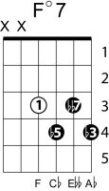
bridge
B♭ B♭m F
Then there was music and wonderful roses
D Gm Gm+Gb(note) Gm+F(note) C7 C+
They tell me in sweet fragrant meadows of dawn and you
verse 2
F F+F#(note)
There was love all around
Gm B♭m
But I never heard it singing
F Am G#m Gm
No I never heard it at all
C F
‘til there was you
solo
bridge
repeat verse 2
C7 F F⁰7 F Fmaj7
Tiiiiiill there was youuuuuuuuuuuuu

