A kiss to build a dream on
Words & Music by Bart Kalmar, Harry Ruby & Oscar Hammerstein II, 1935
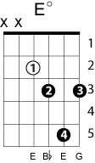

C G C
Give me a kiss to build a dream on,

Edim Cdim G7 Gdim G
And my im - ag - i - na - tion will thrive upon that kiss;
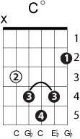
Gdim G
Sweetheart, I ask no more than this,

Dm7 G7 C
A kiss to build a dream on.

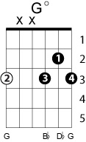
C G C
Give me a kiss before you leave me,

Edim Cdim G7 Gdim G
And my im - ag - i - na - tion will feed my hungry heart
Gdim G
Leave me one thing before we part

Dm7 G7 C Fdim C
A kiss to build a dream on.

Bridge:

Am Fm7 Bb7 Ebmaj7 Eb6
When I'm alone with my fancies
Fm7 Bb7 Ebmaj7 Eb6
I'll be with you
Dm7-5 G7 Cm Cm7
Weav - ing romances,
Am7 D7 Dm7 G7
Making believe they are true.

C G C
Give me your lips for just a moment,

Edim Cdim G7 Gdim G
And my im - ag - i - na - tion will make that moment live

Gdim G
Give me what you alone can give

Dm7 G7 C Fdim(III) Fdim C G Cmaj7

