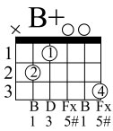
ALL MY LOVING-
The Beatles

Em A7
Close your eyes and I'll kiss you
D Bm
Tomorrow I'll miss you
G Em C A7
Remember I'll always be true
Em A7
And then while I'm away
D Bm
I'll write home every day
G A7 D
And I'll send all my loving to you

I'll pretend that I'm kissing
the lips I am missing
And hope that my dreams will come true
And then while I'm away
I'll write home every day
And I'll send all my loving to you

CHORUS:
Bm Bb+ D
All my loving I will send to you
Bm Bb+ D
All my loving, darling I'll be true

VERSE ONE, CHORUS

Bm D
All my loving, all my loving ...

