Autumn leaves

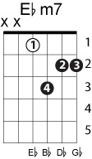
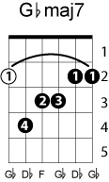
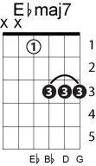
Ebm7 Ab Db AB/C Bbm Fm/Ab Gb7 F7 Bbm Eb/Bb Bbm9
Verse 1
Ebm7 Ab Ab/C Db Db/F Gbmaj7
The falling leaves drift by my window
Ebmaj7 F7 Bbm Eb/Bb Bbm9
The falling leaves of red and gold
Verse 2
I see your lips, the summer kisses
The sunburnt hands I used to hold
Chorus
F7sus4 F7 F7sus4 F7/A Bbm Eb/Bb
Since you went away the days grow long
Ebm7 Ab Db Db/F Gbmag7
And soon I'll hear old winter's song
Ebm7 F7 Bbm Bbm/Ab
But I miss you most of all
Eb7/G Gb
my darling,
F7 Bbm Eb/Bb Bbm9
When Autumn leaves start to fall
(instrumental same chords as verse x2)
Since you went away the days grow long
And soon I'll hear old winter's song
But I miss you most of all
my darling,
When Autumn leaves start to fall

