BECAUSE
BEATLES
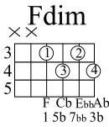

Em Am B7
Because the world is round it turns me on
C Em C7 F Fdim
Because the world is round - Ah, ah
Em Am B7
Because the wind is high, it blows my mind
C Em C7 F Fdim
Because the wind is hi-igh - Ah, ah
A B7
Love is old, love is new, love is all, love is you

Because the sky is blue, it makes me cry
Because the sky is blue - Ah

