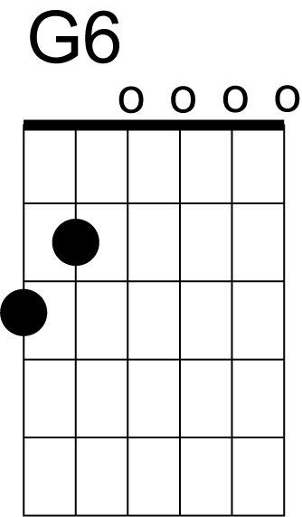
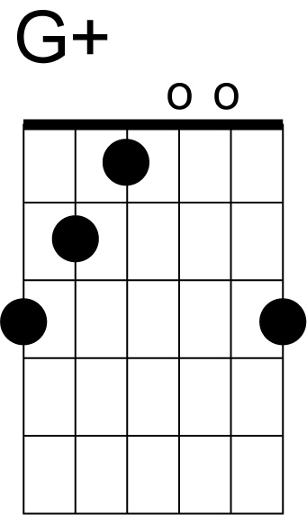
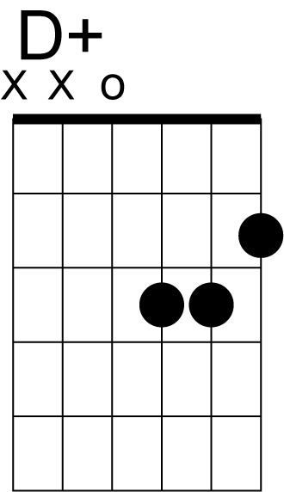
"Because"
(D. Clark - M. Smith) Dave Clark Five
capo 4th fret
Intro:
G G+ G6 G+
/ / / / / / / / / / / / / / / /
Verse 1:
G G+ G6 G7
It's right that I should think about you
Am D D+
And try to make you happy when you're blue
G G+ C Cm
It's right, it's right to feel the way I do
G Am D7 G [1: G7 2: Eb D 3: E7, to coda]
Because, because I love you
Bridge:
Am D G Em
It's wrong to say I don't think of you
Am D
'Cause when you say these things
A7 D D+
You know it makes me blue
Verse 2:
Give me one kiss and I'll be happy
Just, just to be with you
Give me, give me, a chance to be near you
Because, because I love you
Organ solo:
G G+ G6 G7
/ / / / / / / / / / / / / / / /
Am D G Eb D
/ / / / / / / / / / / / / / / /
[repeat verse 2]
Coda:
Am D7 G G6/9

