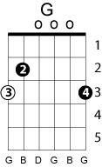
COME AND GET YOUR LOVE
In the film score The Postman
Performed by John Coinman, written by Lolly Vegas
Key: D
Chord progression: 4 – 5 - 1

G – A - D

Hey, hey …hey, hey (reply)
What’s a matter with your head, oh yeah
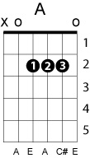
Hey, hey …hey, hey (reply)

What’s a matter with your mind, and your sign, oh yeah
Hey, hey …hey, hey (reply)

Nothin’ the matter with your head baby, find it, come in and find it
Hey, hey …hey, hey (reply)

Win it baby, cause your fine and your mine and you look so divine
Come and get your love
Come and get your love
Come and get your love
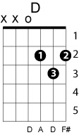
Come and get your love… play riff

Hey, hey …hey, hey (reply)
What’s a matter if you feel right, don’t you feel right baby
Hey, hey …hey, hey (reply)
Get it from the main line, alright
I said find it….find it (reply)
Lordy love, if you like it, oh yeah
Hey, hey …hey, hey (reply)
It’s your business if you want some, take some, get it together baby
Come and get your love
Come and get your love
Come and get your love
Come and get your love… play riff

Come and get your love, come get your love, come get your love now
Come and get your love, come get your love, come get your love now
Come and get your love, come get your love, come get your love now
Come and get your love, come get your love, come get your love now
Hey, hey …hey, hey (reply)
What’s a matter, if you feel right, don’t you feel right baby
Hey, hey …hey, hey (reply)

Come and get it from the main line, alright

Come and get your love
Come and get your love
Come and get your love
Come and get your love…
…. ….

