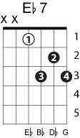
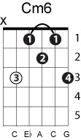
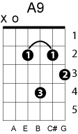
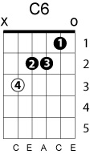
Dream a little dream of me
Mamas & the Papas
(W. Schwendt, F. Andre, G. Kahn)

G | Eb7 D7 | G | E7 Bm7 E7 |
Stars shining bright above you; Night breezes seem to whisper "I love you"

Am Am7 | Cm6 | G A9 | D7 |
Birds singing in the sycamore tree; dream a little dream of me

G | Eb7 D7 | G | E7 Bm7 E7 |
Say nighty-night and kiss me; just hold me tight and tell me you'll miss me

Am Am7 | Cm6 | G Cm7 D7 | C C6 G Bb7 |
While I'm alone and blue as can be, dream a little dream of me

Eb Eb6 | Bb7 | Eb Eb6 | Bb7 Bbo Bb7 |
Stars fading but I linger on dear, still craving your kiss

Eb Eb6 | Bb7 | Eb | D7 Em Am7 D7 |
I'm longing to linger till dawn dear, just saying this:

G | Eb7 D7 | G | E7 Bm7 E7 |
Sweet dreams till sunbeams find you; Sweet dreams that leave all worries...

Am Am7 | Cm6 | G Cm7 D7 | G Eb7 D7 |
But in your dreams whatever they be, dream a little dream of me

