Dream a little dream of me
Mamas & the Papas
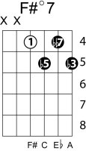
(W. Schwendt, F. Andre, G. Kahn)
Key: C
Intro: G Am Bm C Fº7 Ab G7 C Fº7 Ab G7
Verse 1
Shift to G
Subst. Tritone subst. of D7 back to C
C Fº7 Ab7 G7
Stars shining bright above you
shift to Dm
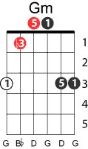
C G/B Gm/Bb A7
Night breezes seem to whisper "I love you"
Subt. rel. major
F Fm
Birds singing in a sycamore tree
C Ab G7
Dream a little dream of me.

Verse 2
Say "Nightie-night" and kiss me
Just hold me tight and tell me you'll miss me
While I'm alone and blue as can be
Shift to Am
C Ab G C E7
Dream a little dream of me.

chorus
A F#m Bm E7 A F#m E7
Stars fading but I linger on, dear, still craving your kiss
A F#m E7 A Ab G7
I'm longing to linger till dawn, dear, just saying this:

Verse 3
Sweet dreams till sunbeams find you
Sweet dreams that leave all worries far behind you
But in your dreams whatever they be
Dream a little dream of me.

C➙Fº7 : changes key to G, should have played D7, instead the
D7 relative minor major partner Fº7 is played, then we play the
tritone substitution of D7 which is Ab7
C➙A7 : A7 is the V of Dm then we expect to go to Dm, instead of Dm
we substitute F, color the F by playing Fm,
➙E7 : the V of Am, the dominant of A, then I vi ii V of A major

