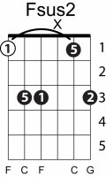
Happy birthday
Key of Eb

Capo 3rd fret

I V Isus4 I
I7 IV I V I

C G
Happy Birthday to you

Csus4 C
Happy Birthday to you

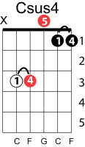
C7 F Fm7
Happy Birthday dear (name)

C G C
Happy Birthday to you.

