Happy Trails
Dale Evans & Roy Rogers

Key of G
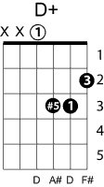
Chorus
G Gdim D7
Happy trails to you until we meet again
D+ G
Happy trails to you, keep smilin' until then
G C
Who cares about the clouds when we're together
Em D7
Just sing a song and bring the sunny weather
G C D7 G

Happy trails to you ‘til we meet again

Some trails are happy ones
Others are blue
It's the way you ride the trail that counts
Here's a happy one for you

{Refrain}

