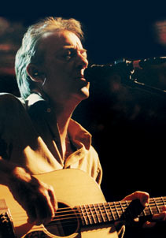
Harbor lights
By Boz Scaggs

Son of a Tokyo Rose I was bound to wander from home
Stranger to whatever I would awaken to Spun the wheel
Took a shot in the dark One way ticket and a run-away heart
Sailor's dream came true the night I dreamed you.
Through the neon doorways Down the stony streets I fell
All hands high side all eyes are red I follow
Sailing shadows reds & blues Curtains drawn but I saw through
The window to your soul and I found you.
Refrain: Whoa oh,oh, oh, the Harbor Lights of (Eden?) shinin' through the breeze
That takes me back To you my love, to you my love, to you my love.....
My eyes must be betrayin' Let that lonesome jukebox playin'
Something 'bout the Harbor Lights is callin' me
Back to some Jamaican Bay Doesn't seem so far away
Keep the change but I'll repay these memories.
Dawn came in this mornin' like some old junked out melody
The words she spoke and we awoke still haunt me
What you feel too Won't reveal you
Let me steal you from my life.
Whoa, oh, oh, oh, the Harbor Lights of (Eden ?) shinin' through the breeze
That takes me back To you my love, to you my love, to you my love.......
Etc.

