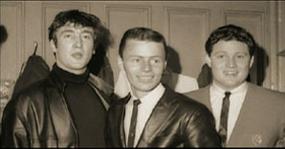
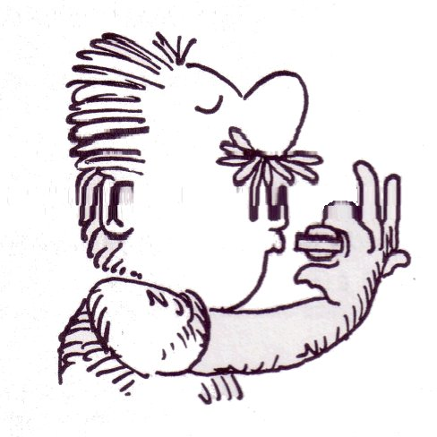

Hey baby
By Bruce Channel
Key: B

Intro

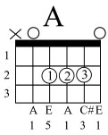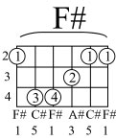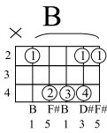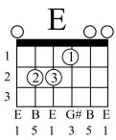

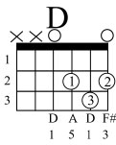
Hey, hey baby! I want to know if you'll be my girl

Hey, hey baby! I want to know if you'll be my girl
When I saw you walking down the street I said that's a kind of girl I'd like to meet
She's so pretty, Lord she's fine I'm gonna make her mine all mine
Hey, hey baby! I want to know if you'll be my girl
When you turned and walked away That's when I want to say
C'mon baby, give me a whirl I want to know if you'll be my girl

Hey, hey baby! I want to know if you'll be my girl

Hey baby (cont.)

When you turned and walked away That's when I want to say
C'mon baby, give me a whirl I want to know if you'll be my girl

Hey, hey baby! I want to know if you'll be my girl
Hey, hey hey hey hey, baby

C'mon, baby now.....

