Hooked On A Feeling
B J Thomas
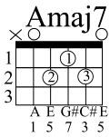
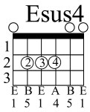
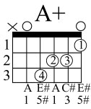
Words and Music by Mark James

INRO: A Amaj7 A7 D Dm A Esus4 E

A Amaj7 A7 D
I can't stop this feelin' deep inside of me
Dm A Esus4 E
Girl, you just don't realize what you do to me
A A+
When ya hold me in your arms so tight
F#m A7
You let me know everything's all right
D E A
I-I-I, I'm hooked on a feelin'
Amaj7 D E A E
High on believin' that you're in love with me
A Amaj7 A7 D
Lips are sweet as candy, the taste stays on my mind
Dm A Esus4 E
Girl, you keep me thirsty for another cup of wine
A Amaj7 A7 D
I got it bad for you, girl but I don't need a cure
Dm A Esus4 E
I'll just stay addicted and hope I can endure

A A+
All the good love when we're all alone
F#m A7
Keep it up, girl, yeah ya turn me on
D E A
I-I-I, I'm hooked on a feelin'
Amaj7 D E A E
High on believin' that you're in love with me

<instrumental interlude>

A A+
All the good love when we're all alone
F#m A7
Keep it up, girl, yeah ya turn me on
D E A
I-I-I, I'm hooked on a feelin'
Amaj7 D E A E
I'm high on believin' that you're in love with me

