How about you
Burton Lane with lyrics by Ralph Freed perf. by Harry Nilsson
Key of D
Subst for C#7
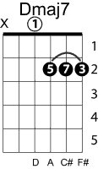
D Dmaj7/A F#m Fº7 Em7 A7
I like New York in June, how about you?

VII7 shift to E ii m7b5(ii of ii) VI+7(V of ii)
D Dmaj7/A F#m Fº7 F#m7b5 B+7
I like a Gershwin tune, how about you?
I7 III bVII subst. back to D V I
E7 C9/G A6 D6
I love a fireside when a storm is due
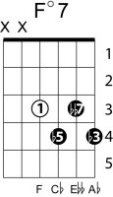
Shift to F#
V of vi back to D
F# D#m G#m C#7 F# Em7 A7
I like potato chips, moonlight, motor trips, how about you?
D Dmaj7 F#m Fº7 Em7 A7
I'm mad about good books, can't get my fill
Shift to G subst.
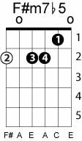
Am Am7 D7 Gmaj7 C9
And James Durante’s looks give me a thrill
back to D
D/A
Holding hands in the movie show
Bb7#5 Em7 F#7
When all the lights are low may not be new
Bm Em7 A7 D
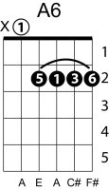
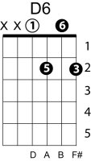
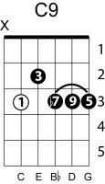
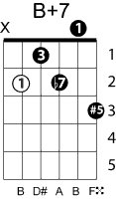
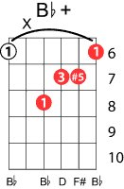
But I like it, how about you?
I like New York in June, how about you?
I like a Gershwin tune, how about you?
I love a fireside when a storm is due, how about you?
I'm mad about good books, can't get my fill
And James Durantes looks they give me a thrill
Holding hands in the movie show
When all the lights are low may not be new
But I like it, and I like it, I like it, how about you?

