
I Just Can't Help Believing
B J Thomas

Capo 1st fret key: E
Intro 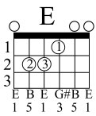 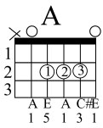
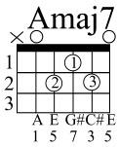
I just can't help believin' When she smiles up soft and gentle
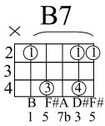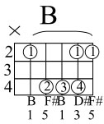
With a trace of misty morning And the promise of tomorrow in her eye-eyes
And I just can't help believin' When she's lyin' close beside me
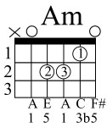
And my heart beats with the rhythm of her si-i-i-ighs
This time the girl is gonna stay
This time the girl is gonna stay for more than just a da-ay
I just can't help believin' When she slips her hand in my hand
A E A
And it feels so small and helpless That my fingers fold around it like a glo-ove
And I just can't help believin' When she's whisperin' her magic
And her tears are shinin' honey sweet with lo-o-o-ove
This time the girl is gonna stay this time the girl is gonna stay
for more than just a da-ay

