I’m confessin’ that I love you
Louis Armstrong - Doc Daugherty & Ellis Reynolds
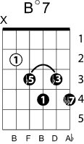
Key of Ab
|Ab Eb+7 | Ab Eb+7 | Ab | F7 |
| Bb7 | Bbm7 Eb7| Ab Bdim7 | Bbm7 Eb7|

Ab Eb+7 Ab Eb+7
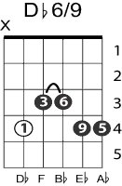
I’m confessin’ that I love you . . .
VI7(V7 of V)²
Ab F7
Tell me, do you love me too?
II7(V7 of V)¹ back to Ab
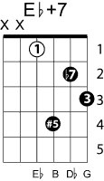
Bb7 Bbm7 Eb7
I’m confessin’ that I need you,
.
Ab Bdim7 Bbm7 Eb7
Honest I do, need you every moment!
Ab Eb+7 Ab Eb+7
In your eyes I read such strange things,
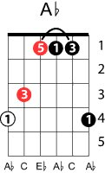
Ab F7
But your lips deny they’re true . . .
Bb7 Bbm7 Eb7
Will your answer really change things,
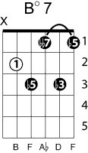
Ab Bdim7 Bbm7 Eb7
Making me blue? Making me blue……
Ab7
I’m afraid someday you’ll leave me,
Db6/9
Say’n can’t we still be friends?
II7(V7 of V)
Bb7
If you go, you know you’ll grieve me,
Eb7 Eb+7
All in life on you depends . . . oh baby
Am I guessin’ that you love me?
Dreamin’ dreams of you in vain,
I’m confessin’ that I love you,
Over again!

