IF I FELL
Beatles
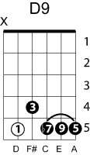
key of D
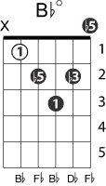
Chord prog.: 1 – 2m – 3m – 2m - 5
Ebm D
If I fell in love with you Would you promise to be true
Db Bbm Ebm
And help me understand 'Cause I've been in love before
D Em A
And found that love is more Than just holding hands
D Em F#m Em7 A D Em F#m
If I give my heart to you I must be sure from the very start
Em7 A D Bbdim A7
That you would love me more than her
D Em F#m Em7 A
If I trust in you Oh please, don't run and hide
D Em F#m Em7 A7 D9
If I love you too Oh please, don't hurt my pride like her
G
Cause I couldn't stand the pain
Gm D A7
And I would be sad if our new love was in vain
D Em F#m Em7 A
So I hope you'll see That I would love to love you
D Em F#m Em7 A Am
And that she will cry When she learns we are two
G
Cause I couldn't stand the pain
Gm D A7
And I would be sad if our new love was in vain
D Em F#m Em7 A7
So I hope you'll see That I would love to love you
D Em F#m Em7 A D
And that she will cry When she learns we are two
Gm D
If I fell in love with you

