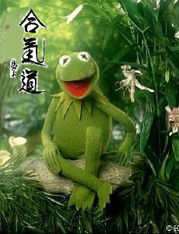
"It's Not Easy Doin’ Aikido " (lyrics by Kermat)

C Em Gm A
It's not that easy doin' aikido; having to spend each day twisting wrists and feet and hands.
Dm
When I think it could be nicer lying down or drinking beer or laughing
G C G
or something different like that.
C Em Gm
It's not easy doin’ aikido. Everything is in Japanese and kind of twisty and twirly and flying
A
around on one leg
Dm G C C7
And I think it would be nice to throw all the time and not have to worry about some jerk twisting my arm

F Fm
But aikido is nice and friendly like.
C C7 F
even though I’m stiff and block like. There are good people like Nick, Mike, MJ, Serge, Neil, Tracy
Fm G
and Ed and others that I should mention, all now good friends

C Em Gm
It’s not easy doin’ aikido We have to put up the mats every night,
A Dm G
why? I wonder, but why wonder. I wouldn’t miss it for the world!
C F C
And it’s where I want to be……NO it’s not easy…………………….Aaaahhh,..shut dap!!!!

