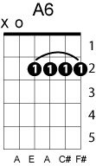
Just like starting over
John Lennon
Key of A
Ascending augmented progression

A A+ A6 A+
Our life together is so precious together.
A E7 A E7
We have grown, we have grown
A A+ A6
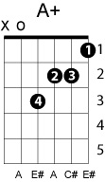
although our love is still special.
A7 D
Let’s take a chance and fly away
Dm A
somewhere alone.

A
It’s been too long since we took the time.
A(#5) Bm E
No-one’s to blame, I know time flies so quickly
Bm E
but when I see you darling
C#m F# Bm
it’s like we both are falling in love again.
E A A(#5) A A(#5)
It’ll be just like starting over, starting over.

Everyday we used to make it love.
Why can’t we be making love nice and easy?
It’s time to spread our wings and fly.
Don’t let another day go by my love,
it’ll be just like starting over, starting over.

G Am
Why don’t we take off alone,
D G
take a trip somewhere far, far away.
Em Am
We’ll be together on our own again
D G
like we used to in the early days,
E7
well, well darling.

It’s been too long...

Our life together...

