Just the way you are
B.JOEL
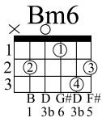
D Bm6 G7+ Bm G7+ Gm D
Don't go changin' to try please me you never let me down before
Am D7 G7+ Gm D Bm
Mm Don't imagine you're too familiar
E E7 Asus4 A D
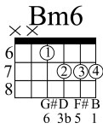
And I don't see you anymore

D Bm6 G7+ Bm
I would not leave you in times of trouble
G7+ Gm D
we never could have come this far
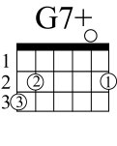
Am D7 G7+ Gm D Bm
Mm I took the good times I'll take the bad times
Em7 Asus4 D Gm D G D Gm D G
I'll take you just the way you are

G A Gbm7 B7
I need to know that you will always be
Em A D D7 Am
the same old someone that I knew
Bb C Am D7
What will it take till you believe in me MTM
Gm C Asus4 A
The way that I believe in you

D Bm6 G7+ Bm
I said I love you & that's forever
G7+ Gm D
& this I promise from the heart
Am D7 G7+ Gm D Bm
Mm I could not love you any better
Em7 A4 D Gm D G D Gm D G
I'll love you just the way you are

solo

D Bm6 G7+ Bm G7+ Gm D
I don't want clever conversation I never want to work that hard
Am D7 G7+ Gm D Bm
Mm I just want someone that I can talk to
Em7 Asus4 Bb C Am D7 Gm C
I'll want you just the way you are
D Bm6 G7+ Bm G7+ Gm D Am^D7 G7+ Gm D Bm...... .

