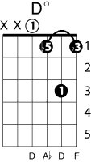
Michelle
Lennon/McCartney

Intro: Fm Fm/E Fm/Eb Fm/D C#m C7 (play the Fm as an A form,
descending bass line on the 5th string, but easier to do as an E form descending bass line on the 4th string)

F Bbm7 Eb6 D⁰ C G7 C
Michelle, ma belle, these are words that go together well, my Michelle
F Bbm7 Eb6 D0 C G7 C
Michelle, ma belle, sont des mots qui vont très bien ensemble, tres bien ensemble

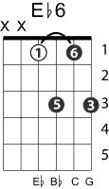
Fm Ab7 Db
I love you, I love you, I love you, that's all I want to say
C7 Fm
until I find a way
Fm Fm#7 Fm7 Fm6 Bbm/F C7
I will say the only words I know that you'll understand.

Chorus

I need you, I need you, I need you, I need to make you see
oh what you mean to me
until I do I'm hoping you will know what I mean

F Bbm7 Eb6 D⁰ C G7 C
I love you ….

Chorus

I want you, I want you, I want you, I think you know by now
I'll get to you somehow
until I do I'm telling you so you'll understand

F Bbm7 Eb6 D0 G7-9 C G7 C
Michelle, ma belle sont des mots qui vont très bien ensemble, très bien ensemble
F Bbm7 C Fm C F
I will say the only words I know that you'll understand, my Michelle

