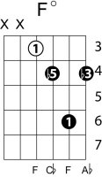
My Sweet Lord
George Harrison
Key of E
Intro: F#m B x 4 E C#m x 2 F^{O} F#m B
F#m B
My sweet Lord
F#m B
Mm, my Lord
F#m B
Mm, my Lord

Verse 1
E C#m
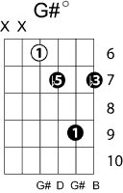
I really want to see you
E C#m
Really want to be with you
E
Really want to see you, Lord
Fº F#m B
But it takes so long, my Lord

F#m B
My sweet Lord
F#m B
Mm, my Lord
F#m B
Mm, my Lord

Verse 2
I really want to know you
I really want to go with you
Really want to show you, Lord
That it won't take long, my Lord Hallelujah

My sweet Lord Hallelujah
Mm, my Lord Hallelujah
My sweet Lord Hallelujah
E
I really want to see you
E7
Really want to see you
C#7
Really want to see you Lord
Key shift up 1 tone
F#
Really want to see you Lord
G^{O} G#m C#
But it takes so long, my Lord Hallelujah

G#m C#
My sweet Lord Hallelujah
G#m C#
Mm, my Lord Hallelujah
G#m C#
My my my Lord Hallelujah

Verse 2 repeat My Lord…..

