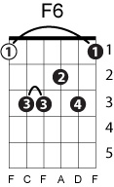
Na na hey hey kiss him goodbye
Steam
Written by: De Carlo/Frshuer/Leka

Key of C
INTRO:
|C / / /|Eb / / /|Bb / / /C|

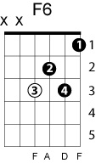
C Eb Bb C
Na na na na, na na, hey hey-ey, goodbye

VERSES:
C F6 G C F6 G
He'll never love you, the way that I love you
C Am Dm G
'Cause if he did, no no, he wouldn't make you cry
F E7 Am F
He might be thrillin' baby but a-my love (my love, my love)
C F Fm
So kiss him (I wanna see you kiss him. Wanna see you kiss him)
C
Goodbye now

CHORUS:
Eb Bb C
Na na na na, hey hey-ey, goodbye
C Eb Bb C
Na na na na, na na, hey hey-ey, goodbye

C F6 G C F6 G
He's never near you to comfort and cheer you
C Am Dm G
When all those sad tears are fallin' baby from your eyes

F E7 Am F
He might be thrillin' baby but a-my love (my love, my love)
C F Fm
So kiss him (I wanna see you kiss him. I wanna see you kiss him)
C
Goodbye

Eb Bb C
Na na na na, hey hey-ey, goodbye

C Eb B C (fade out)
Na na na na, na na, hey hey-ey, goodbye

