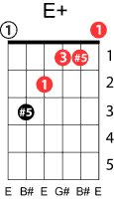
Only you
Platters - Buck Ram

Key of Eb
Capo 3rd fret
Intro; G7 F# G7

Verse 1
C E7
Only you can make this world seem right,

Am C7
Only you can make the darkness bright.

F G7 C E7 Am E+ Am7
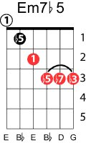
Only you, and you alone, can thrill me like you do,

D7 Dm7 G7
And fill my heart with love for only you.

Verse 2
C E7
Only you can make this change in me,

Am C7
For it's true, you are my destiny.

F Fm C C/B A7
When you hold my hand, I understand the magic that you do -

Em7b 5 D7 G7 C Dm7 C
You're my dream come true, my one and only you.

Repeat verse 2

(Instrumental interlude: all but last line above)

D7 G7 C Fm C C6
You're my dream come true, my one and only you.

