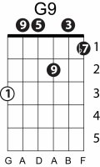
Pennies from heaven
Billie Holiday - Arthur Johnston & Johnny Burke
Key of F
Capo 5th fret to play along with Billie

C Dm7 Em7 Ebdim Dm7 G7 Dm7 G7
Every time it rains, it rains pennies from heaven
C Dm7 Em7 Ebdim Dm7 G7 Dm7 G7
Don't you know each cloud contains pennies from heaven?
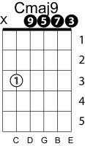
C7 F C7 F A7
You'll find your fortune's fallin' all over the town
D7 G7 G9
Be sure that your umbrella is upside down
C Dm7 Em7 Ebdim Dm7 G7 Dm7 G7
Trade them for a package of sunshine and flowers
C Dm7 C7 Fmaj7 F6
If you want the things you love, you must have showers
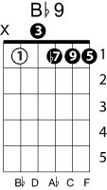
F Bb9#11 Cmaj9 A9
So, when you hear it thunder, don't run under a tree
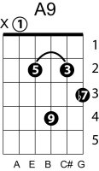
Dm7 G6 C Dm7 C
There'll be pennies from heaven for you and me
[lengthy instrumental-sax solo and then brass]
