Reach out
The Four Tops
Key of Ebm
Capo 1st fret
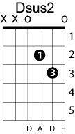
Dsus4 Dm (x2) Dsus2 A (whole thing x2)
Gm C
If you feel that you can't go on
Gm C
Because all of your hope is gone
Gm C
And your life is filled with much confusion
Gm C
Until happiness is just an illusion
Gm C
And your world around is falling down
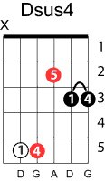
F A Bb
Darling, reach out Reach out____
A Dm A
I'll be there, to give you all the love you need
A Dm A Asus4 A
I'll be there, you can always depend on me
Gm C
If you feel that you can't go on
Gm C
Because all of your hope is gone
Gm C
And your life is filled with much confusion
Gm C
Until happiness is just an illusion
Gm C
And your world around is tumbling down
F A Bb
Darling, reach out Reach out____
A Dm A
I'll be there, to give you all the love you need
A Dm A Asus4 A
I'll be there, you can always depend on me

Dsus4 Dm (x2) Dsus2 A (whole thing x2)
Gm C
Well if you're lost and about to give up
Gm C
Because your best just ain't good enough
Gm C
And your life is filled with much confusion
Gm C
Until happiness is just an illusion
Gm C
And your world around is tumbling down
F
Darling, reach out (c'mon baby)
A Bb
Reach out_______
A Dm A
I'll be there, to love and see you through
A Dm A
I'll be there, you can always depend on me

A Dm A
I'll be there, to love and see you through
A Dm A
I'll be there, you can always depend on me

Repeat intro

