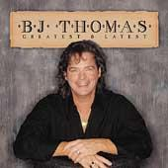
Rock and Roll Lullaby
by B.J. Thomas

capo 1st fret maybe…key: G
G C
She was just sixteen and all alone When I came to be
D C G
So we grew up together My mama child and me
C Am
Now things were bad and she was scared But whenever I would cry
D C G
She'd calm my fears and dry my tears With a rock and roll lullaby
C Am
Refrain
And she would sing sha na na na na na na na ...It will be all right sha na na na na na....
C G
Sha na na na na na na na ...Now just hold on tight
Am
Sing it to me mama (mama mama ma) Sing it sweet and clear, oh!
C Am G
Mama let me hear that old rock and roll lullaby

Solo

G C Am
We made it through the lonely days But Lord the nights were long
D C G
And we’d dream of better moments When mama sang her song
C Am
Now I can't recall the words at all It don't make sense to try
D C G
'Cause I just knew lots of love came thru In that rock and roll lullaby
