SUMMERTIME 2
(Gershwin)

Intro: ||: Dm6 Am7 :||

A+ Dm6 A7 Dm6 A7 Dm6 A7 Dm6
Summertime, and the livin' is easy;
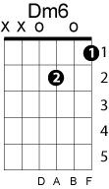
A7 Gm7 Bb6 Gm7 BbM7 Fdim A E7+9 A Am7
Fish are jumpin', and the cotton is high.

A7-5 Dm6 A7 Dm6 A7 Dm6 A7 Dm6 G7
Yo' daddy's rich and yo' mama's good-lookin',

F Dm G Gm7 Dm Dm+7 Dm6 A7
So hush, little baby, don't you cry.
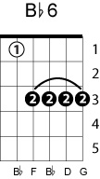

A+ Dm6 A7 Dm6 A7 Dm6 A7 Dm6A7
One of these mornin's, you're gonna rise up singin';

Gm7 Bb6 Gm7
You're gonna spread your wings

BbM7 Fdim A E7 A Am7
And take to the sky.

A7-5 Dm6 A7 Dm6 A7 Dm6 A7 Dm6
But 'til that mornin', ain't nothin' can harm you

G7 F Dm G Gm7 Dm
With daddy and mammy stan - din' by.

Instrumental Coda:

A7 Bb9 A7 Dm

