Saturday in the Park
Chicago
Key of G, falling fifths modulation
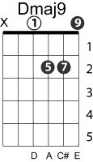
Intro: Am7 D7 G7 C x 3

Am7 D7
Saturday in the park
G7 C
I think it was the Fourth of July
Am7 D7
Saturday in the park
G7 C
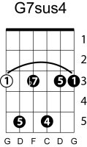
I think it was the Fourth of July
Bm7 Em7
People dancing, people laughing
Dmaj9
A man selling ice cream
C D
Singing Italian songs

G G7sus4
Eicay varé, eisé nardé
C G
Can you dig it, yes I can
Am7
And I've been waiting such a long time
D7
For Saturday

Another day in the park, I think it was the Fourth of July
Another day in the park, I think it was the Fourth of July
People talking, really smiling, A man playing his guitar
And singing for us all

Will you help him change the world
Can you dig it, yes I can
And I've been waiting such a long time
For today
shift to F
Gm C7 Gm C7
Slow motion riders fly the colors of the day
shift to Ab
Bbm7 Eb7 Bbm7 Eb7
A bronze man still can tell stories his own way
shift to C
Dm7 G7
Listen children all is not lost
Dm7 G7
All is not lost, oh no, no

back to G
Funny days in the park, And every day's the Fourth of July
Funny days in the park, Every day's the Fourth of July
People reaching, people touching’ A real celebration
Waiting for us all

If we want it, really want it
Can you dig it, yes I can
And I've been waiting such a long time
For the day

