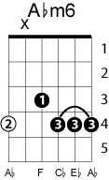
September Song
Willie Nelson – M. Anderson, K. Weill

Key: A♭ (this is the key that Willie sings it in)
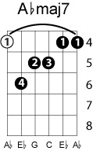
A♭ A♭m6 E A♭
Oh it’s a long long time from May to December
A♭maj7 A♭7 B♭7 D♭m E♭7 A♭
But the days grow short when you reach September
A♭ A♭m6 E A♭
When the autumn weather turns leaves to flame
A♭maj7 A♭7 B♭7 D♭m E♭7 A♭
One hasn’t got time for the waiting game
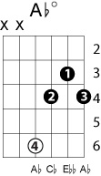
D♭m A♭dim
Oh the days dwindle down to a precious few
D♭m A♭dim
September November
A♭m6 E A♭
and these few precious days I’ll spend with you
A♭maj7 A♭7 B♭7 D♭m Edim7 A♭
These precious days I’ll spend with you
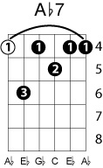

Solo of melody….

D♭m A♭dim
Oh the days dwindle down to a precious few
D♭m A♭dim
September November
A♭m6 E A♭
and these few precious days I’ll spend with you
B♭7 D♭m Edim7 A♭ D♭m A♭
These precious days I’ll spend with you

