Small Town
John Mellencamp
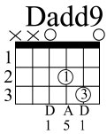
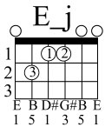
[A]Well I was [Esus2]born in [Dadd9]small town
[A]and I [Esus2]live in a [Dadd9]small town
[A]Prob'ly [Esus2]die in a [Dadd9]small town
Oh those [Bm]small communi[E]ties

All my friend are so small town
My parents live in the same small town
My job is so small town
Provides little opportunity

Educated in a small town
Taught the fear of jesus in a small town
Used to daydream in that small town
another boring romantic that’s me

But I've seen it all in a small town
Had myself a ball in a small town
Married an an L.A doll and brought her to this small town
now she's small town just like me

{Bridge}
[D]No I cannot [A]forget where it [D]is that I come [A]from
[D]I cannot [A]forget the people who [E]love me
[D]Yeah I can be [A]myself [D]here in this small [A]town
[D]and people [A]let me be just what [E]I want to be

D A D..A (repeat)
{c:Solo over verse chords}

Got nothing against the big town
Still hayseed enough to say look who’s in the big town
but my bed is in a small town
Oh and that’s good enough for me

Well I was born in a small town
and I can breathe in a small town
Gonna die in this small town
and that’s probly where they'll bury me

