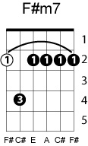
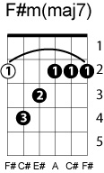
SOMETHING
BEATLES
Key of A as George sings it
Chord progression: I Imaj7 I7 (or V7^{IV}) IV V7^{V} VI

A Amaj7
Something in the way she moves,
A7 D/F# (notes D, C#, B)
Attracts me like no other lover
B7 E F#m G#m
Something in the way she woos me

F#m F#m(maj7) F#m7 B7 D
I don't want to leave her now, you know I believe and how

Somewhere in her smile she knows,
That I don' need no other lover
Something in her style that shows me

Chorus
……
F# F#maj7 F#7 F# B E F#
You're asking me will our love grow, I don’t know, I don’t know
F# F#maj7 F#7 F# B E A
You stick around now it may show, I don’t know, I don’t know

Something in the way she knows,
And all I have to do is look at her
Something in the things she shows me

