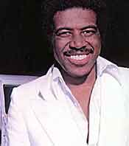
Standby me
Ben E. King

A F#m
When the night has come and the land is dark,
D E A
And the moon is the only light we'll see.
F#m
No I won't be afraid, Oh I won't be afraid,
D E A
Just as long as you stand, stand by me
So darlin' darlin' stand by me, Oh stand by me,
F#m D E A
Oh stand, stand by me, stand by me.
F#m
If the sky that we look upon should tumble and fall,
D E A
Or the mountain should crumble to the sea.
F#m
I won't cry, I won't cry, No I won't shed a tear,
D E A
Just as long as you stand, stand by me.
F#m
And darlin' darlin' stand by me, Oh stand by me,
D E A
Whoa stand now, stand by me, stand by me.
F#m
Darlin' darlin' stand by me, Oh stand by me,
D E A
Oh stand now, stand by me, stand by me.
Whenever you're in trouble just stand by me,
F#m D E A
Oh stand by me, Whoa stand now, oh stand, stand by me.

