Stardust

Willie Nelson version

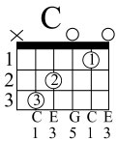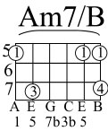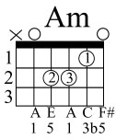
Sometimes I wonder why I spend the lonely nights dreaming of a song
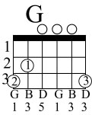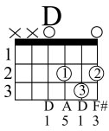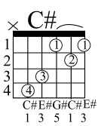
That melody haunts my reverie and I am once again with you
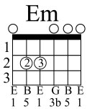
When our love was new and each kiss an inspiration
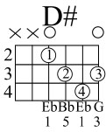
Ah, but that was long ago now my consolation Is in the stardust of a song
Beside a garden wall where stars are bright you are in my arms
that nightingale tells its fairy tale of paradise where roses grew
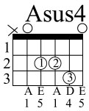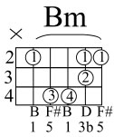
Though I dream in vain in my heart there always will remain
my stardust melody the memory of love's refrain.

Solo
Though I dream in vain in my heart there always will remain
my stardust melody the memory of love's refrain.

Solo
Though I dream in vain in my heart there always will remain
my stardust melody the memory of love's refrain.

