The Galaxy Song
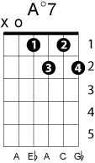
Monty Python
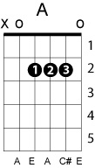
[Meaning of Life, the]

{Spoken, loosely}
Whenever life get you down, Mrs. Brown
And things seem hard or tough
And people are stupid, obnoxious or daft
And you feel that you've had quite enu-hu-hu-huuuuff

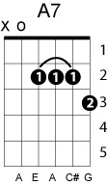
/ Adim7 A / A7 A / Adim7 A F# / B E7 /

Just remember that you're standing on a planet that's evolving
And revolving at 900 miles an hour
That's orbiting at 19 miles a second, so it's reckoned
A sun that is the source of all our power
The sun and you and me, and all the stars that we can see
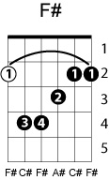
Are moving at a million miles a day
In an outer spiral arm, at 40,000 miles an hour
Of the galaxy we call the Milky Way

/ A Amaj7 A6 A / A A6 E7 - / - Bm7 E Bm7 / E7 Bm7 A - /
/ 1st / F#7 - Bm - / D Adim7 A F#7 / Bm E7 A - /

Our galaxy itself contains 100 billion stars
It's 100,000 light-years side-to-side
It bulges in the middle, 16,000 light-years thick
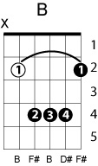
But out by us it's just 3000 light-years wide
We're 30,000 -years from galactic central point
We go round every 200 million years
And our galaxy is only one of millions of billions
In this amazing and expanding universe

The universe itself keeps on expanding and expanding
In all of the directions it can whiz
As fast as it can go, at the speed of light you know
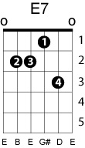
Twelve million miles a minute and that's the fastest speed there is
So remember, when you're feeling very small and insecure
How amazingly unlikely is your birth
And pray that there's intelligent life somewhere up in space
Because there's bugger all down here on Earth
