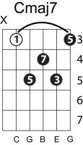
The nearness of you
Norah Jones – Hoagy Carmichael
Key of C
Cmaj7 Cmaj9 Gm7 C9 Fmaj7 Fdim
It’s not the pale moon that excites me That thrills and delights me,

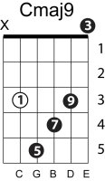
Em7 A7b9 Dm7 G13b9 Em7 A7b9 Dm7 F/G G13b9
oh no Its just the nearness of you

Cmaj7 Cmaj9 Gm7 C9 Fmaj7 Fdim
It isn’t your sweet conversati on That brings this sensation,
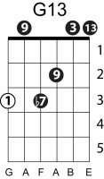

Em7 A7b9 Dm7 G13b9 B/C C C
oh no Its just the nearness of you
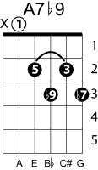
Fm G+7#9 Cmaj9 C9

When you’re in my arms and I fee l you so close to me

Fmaj7 Em7 A7b9 Dm7 C/E F F#dim F/G G13b9
All my wildest dreams come true

Cmaj7 Dm7 D#m7 Em7 Gm7 C9

I need no soft lights to enchant me

Fmaj7 Fdim Em7 A7 Dm7
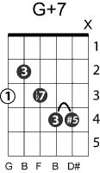
If you’ll only grant me the right

G7 Em7 A7(b9)
To hold you ever so tight

Dm7 C/E F F#dim F/G G13(b9) B/C C B/C C
And to feel in the night the nearness of you

(Fmaj7)
