THIS BOY
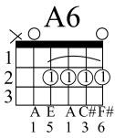
BEATLES

D Bm G A7

D Bm G A D Bm G
That boy, took my love away
A7 D Bm
Though he'll regret it someday
G A6 D Bm G A7
This boy wants you back again

That boy, isn't good for you

Though he may want you too
G A6 D Bm D7 ....
This boy wants you back again

Chorus
G F#m
Oh and this boy, would be happy
Bm A7
Just to love you, but oh my-y-y-y
G F# A7 A6
That boy won't be happy till he sees you cry-y-y

This boy wouldn't mind the pain

Would always feel the same

Till this boy gets you back again

Repeat Chorus

