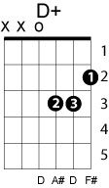
Turn Around, Look At Me
The Vogues
Key of D
Chord progression: 5(7) – 1 – 4 – 1 – 5 – 2m – 5(7)

Verse 1
A7 D G9 D G9
There is someone..walking behind you..
Em Em7 A7
Turn around...look at me.
Em Em7 A7
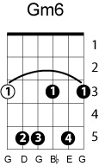
There is someone....watching your footsteps..
D Dmaj7 D7
Turn around..look at me.
G F#7
There is someone who really needs you..
Bm E7
Here's my heart in my hand.
D D+ Bm Dmaj7 G9 Gm6 Em7 A7 D
Turn around....look at me, understand, understand...

Verse 2
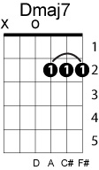
A7 D G9 D G9
That there's someone.. who'll stand beside you...
Em Em7 A7
Turn around...look at me.
Em Em7 A7
And there's someone....who'll love and guide you...
D Dmaj7 D7
Turn around...look at me.
G F#7
I've waited, but I'll wait forever,
Bm E7
For you to come to me.
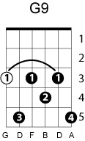
D D+ Bm Dmaj7
Look at someone....who really loves you..
G9 A A7 D G D
Turn around...look..at..me.

