Twilight time
The Platters
Key of G
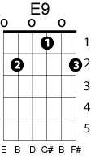
Capo 2nd fret
bIII
G B
Heavenly shades of night are falling, it's Twilight Time
Em7 G
Out of the mist your voice is calling, it's Twilight Time
parallel minor substitution
C Cm
When purple colored curtains
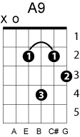
shift to Am
G E9
mark the end of day
shift to Dm back to G
A9 D11 D9
I hear you, my dear at Twilight time
G B
Deeping shadows gather splendor as day is done
Em7
fingers of night will soon surrender
G
the setting sun
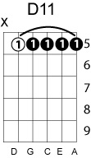
C Cm
I count the moments darling
G E9
till you're here with me
A9 D G
together at last at twilight time
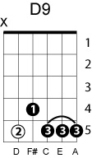
shift to Em
B7
Here in the after glow of day
Em7
we keep our rendezvous
C Em
be-------neath
C Em
the blue
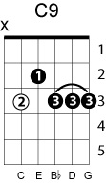
shift to Dm
A9
Here in the sweet and same old way
back to G
D9 C9
I fall in love again as
bVII
D7 Eb7 D7
I did then

G B
Deep in the dark your kiss will thrill me like days of old
Em7
lighting the spark of love that fills me
G
with dreams untold
C Cm
Each day I pray for evening
G E9
just to be with you
A9 D7 G
together at last at Twilight Time

