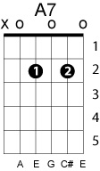
Who Says
John Mayer
Key of D

D G
Who says I can’t get stoned?
Em A7 Bbdim
Turn off the lights and the telephone
Bm E
Me and my house alone
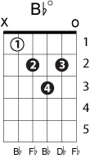
G A D
Who says I can’t get stoned?

D G
Who says I can’t be free?
Em A7 Bbdim
From all of the things that I used to be
Bm E
Re-write my history
G A D
Who says I can’t be free?

G D/F# A
It’s been a long night in New York City
G D/F# A
It’s been a long night in Baton Rouge
G D F# Bm
I don’t remember you looking any better
E A Bm C#m
But then again I don’t remember you
Who says I can't get stoned?
Call up a girl that I used to know
Fake love for an hour or so
Who says I can't get stoned?
Who says I can't take time?
Meet all the girls in the county line
Wait on fate to send a sign
Who says I can't take time?
It's been a long night in New York City
It's been a long night in Austin too
I don't remember you looking any better
But then again, I don't remember you
intermede
Who says I can't get stoned?
Plan a trip to Japan alone
Doesn't matter if I even go
Who says I can't get stoned?
It's been a long night in New York City
It's been a long time since 22
I don't remember you looking any better
But then again, I don't remember, don't remember you

