You are wonderful tonight
By Eric Clapton

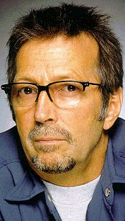
G D/F# C D G D/F# C D

G D/F#
It's late in the evening
C D
She's wondering what clothes to wear
G D/F#
She puts on her make up
C D
And brushes her long blonde hair
C D
And then she asks me
G Bm/F# Em
Do I look alright
C D G D/F# C D
And I say yes, you look wonderful tonight

G D/F#
We go a party
C D
And everyone turns to see
G D/F#
This beautiful lady
C D
That's walking around with me
C D
And then she asks me
G Bm/F# Em
Do you feel alright
C D G
And I say yes, I feel wonderful tonight

C
I feel wonderful
D G Bm/F# Em
Because I see the love light in your eyes
C D
And the wonder of it all
C D
Is that you just don't realize
G D/F# C D G D/F# C D
How much I love you

G D/F#
It's time to go home now
C D
And I've got an aching head
G D/F#
So I give her the car keys
C D
She helps me to bed
C D
And then I tell her
G Bm/F# Em
As I turn out the light
C D G Bm/F# Em Em/D
I say my darling, you were wonderful tonight
C D G D/F# C D G D/F# C D G
Oh my darling, you were wonderful tonight

