You belong to me
Pee Wee King, Chilton Price, and Redd Stewart
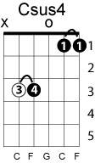
Capo 6th fret
Key of C
Intro: C Em F C F Fm C Am Dm G7sus4 C

C Em
See the pyramids along the Nile
F C
Watch the sunrise from a tropic isle
F Fm C Am
Just remember, darling all the while
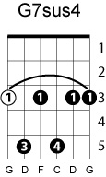
Dm G7sus4
You belong to me
C Em
See the marketplace in old Algiers
F C
Send me photographs and souvenirs
F Fm C note-B Am
Just remember when a dream appears
Dm G7sus4 C
You belong to me

bridge
C C7 F
I'll be so alone without you
D7 G Csus4
Maybe you'll be lonesome too And blue

Fly the ocean in a silver plane
See the jungle when it's wet with rain
Just remember 'til you're home again
You belong to me

[instrumental verse, as intro]

I'll be so alone without you
Maybe you'll be lonesome too
And blue

Fly the ocean in a silver plane
See the jungle when it's wet with rain
Just remember 'til you're home again
You belong to me

