YOU DON'T KNOW ME
EMMYLOU HARRIS / JAN ARDEN
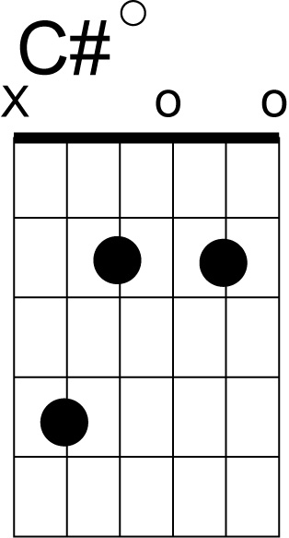
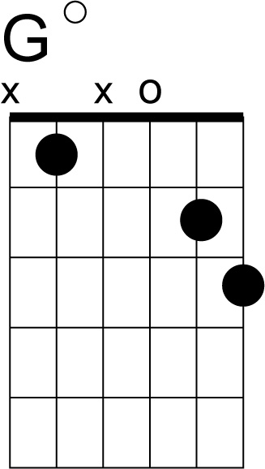

G D7

G G7 C
You give your hand to me and then you say hello and I can hardly speak
C#dim
My heart is beating so
G E7 Am
And anyone could tell you think you know me well
D7 G Am D7
but you don't know me
G G7
No you don't know the one who dreams of you at night
C C#dim
And longs to kiss your lips and longs to hold you tight
G E7 Am
I'm just a friend that's all I've ever been
D7 G G7 G
But you don't know me

C Gdim Gmaj7
For I never knew the art of making love
Am D7 G
Though my heart aches with love for you
Em Bm
Afraid and shy I let my chance go by
A7 D7
The chance that you might love me too

G G7
You give your hand to me and then you say goodbye
C C#dim
I watch you walk away beside the lucky guy
G E7 Am D7 G
Oh you will never know the one who loves you so cause you don't know me

SOLO

C Gdim Gmaj7
Am D7 G
Em Bm
A7 D7

G
G G7
You give your hand to me and then you say goodbye
C C#dim
I watch you walk away beside the lucky guy
G E7 Am D7 G
Oh you will never know the one who loves you so cause you don't know me

