
YOU'LL NEVER WALK ALONE
(R. Rodgers - O. Hammerstein II)
Key: C

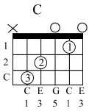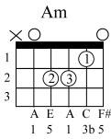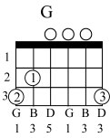
When you walk through the storm Hold your head up high

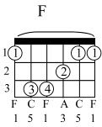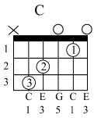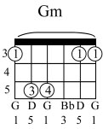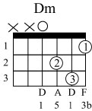
And don't be afraid of the dark At the end of the storm

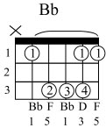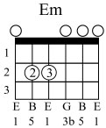
There's a golden sky And the sweet silver song of the lark

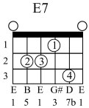
Walk on, through the wind Walk on, through the rain

Though your dreams be tossed and blown
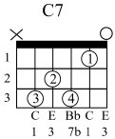
Walk on, walk on, with hope in your heart
And you'll ne______ver walk alone
You'll ne____ver walk alone

Walk on, walk on, with hope in your heart
And you'll never walk alone
You'll ne ver walk a_____lone

