More than words
Lyrics and Music by Nuno Bettencourt and Gary Cherone
1990

slower than you think, guitar rapping
Down tune ½ tone key: G
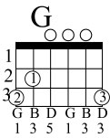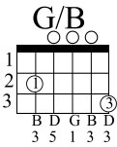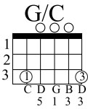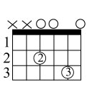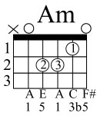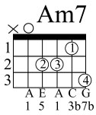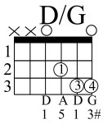repeat
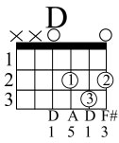
Saying ' I Love you' is not the words I want to hear from you
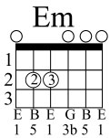
It's not that I want you not to say But if you only knew
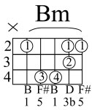
How easy it would be to show me how you feel More than words is all you have to do
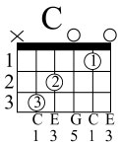 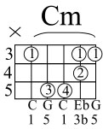 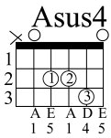
To make it real then you wouldn't have to say That you love me cause I'd already know
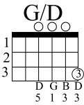
What would you do if my heart was torn in two
More than words to show you feel That your love for me is real
What would you say if I took those words away
Then you couldn't make things new Just by saying I love you
More than words
Now I've tried to talk to you And make you understand

More than words (cont.)

all you have to do is close your eyes and just reach out your hands
And touch me hold me close Don't ever let me go More than words is all I ever needed
you to show Then you wouldn't have to say That you love me 'cause I already know
What would you do if my heart was torn in two
More than words to show you feel That your love for me is real
What would you say if I took those words away
Then you couldn't make things new Just by saying I love you
More than words
More than words

