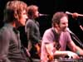
100 years
Five for fighting

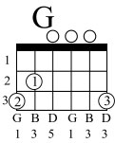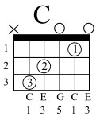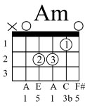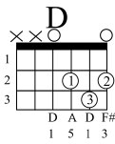
I'm fifteen for a moment Caught in between ten and twenty
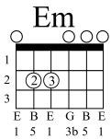
And I'm just dreaming Counting the ways to where you are
I'm twenty two for a moment She feels better than ever
And we're on fire Making our way back from Mars
Fifteen there's still time for you Time to buy and time to lose
repeat
fifteen, there's never a wish better than this When you only got a hundred years to live
I'm thirty three for a moment Still the man, but you see I'm a they
A kid on the way babe A family on my mind
I'm forty five for a moment The sea is high
And I'm heading into a crisis Chasing the years of my life
Fifteen there's still time for you Time to buy, Time to lose yourself
Within a morning star fifteen I'm all right with you

100 years (cont.)

Fifteen, there's never a wish better than this
When you only got a hundred years to live
Half time goes by Suddenly you’re wise
Another blink of an eye sixty seven is gone
The sun is getting high We're moving on...
I'm ninety nine for a moment Dying for just another moment
And I'm just dreaming Counting the ways to where you are
Fifteen there's still time for you twenty two I feel her too
Thirty three you’re on your way Every day's a new day...
Fifteen there's still time for you Time to buy and time to choose
Hey fifteen, there's never a wish better than this When you only got one hundred years to live

